**Area 25**

**International Speech**

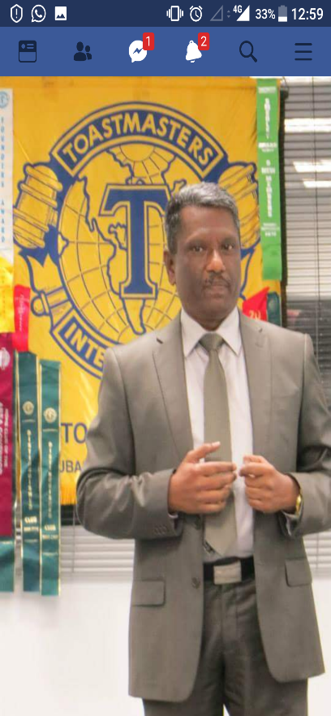 TM Velu Arumugam

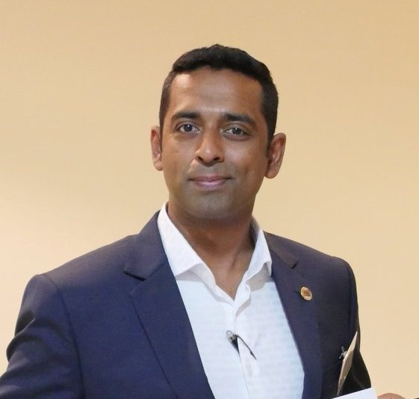TM Yasir

**Evaluation**

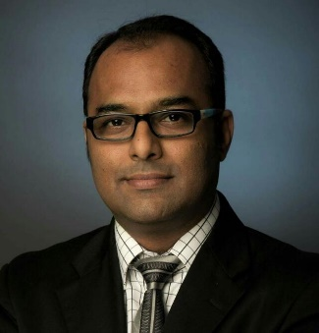TM Devesh Vithlani

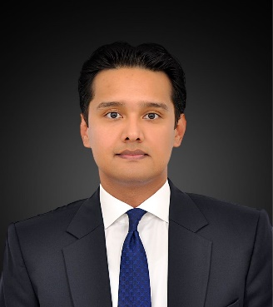TM Shamsher Swar

**Table Topics**

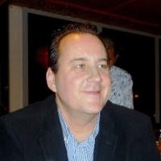 TM Greg Pogonowski

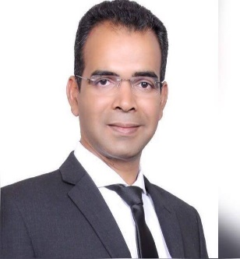 TM Aravindakshan

**Humorous Speech**

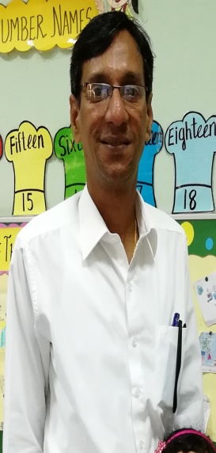TM Keerthivasan

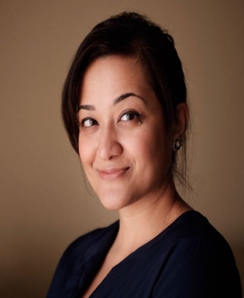 TM Nausheen Shafeek

**Area 27**

**International Speech**

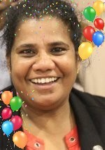TM Annamma Lucy

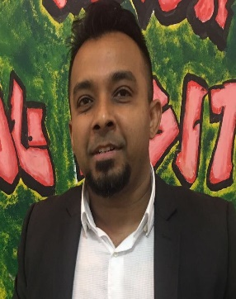TM Hashim Haleem

**Evaluation**

TM Hashim Haleem

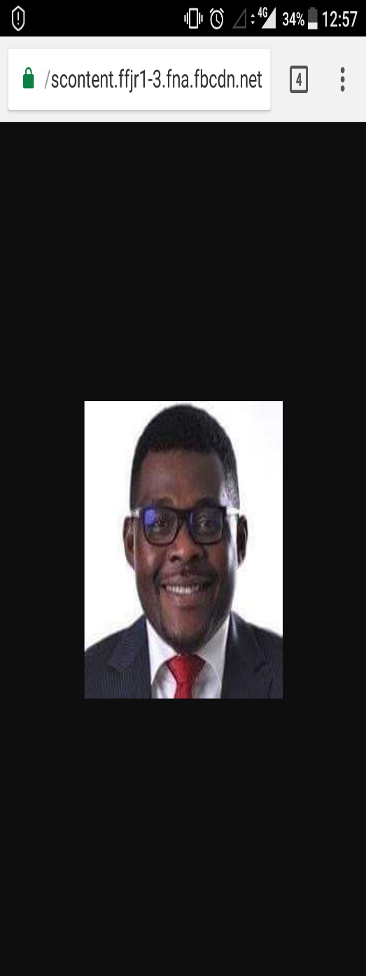 TM Philip Nwosisi

**Area 27**

**Table Topics**

TM Hashim Haleem

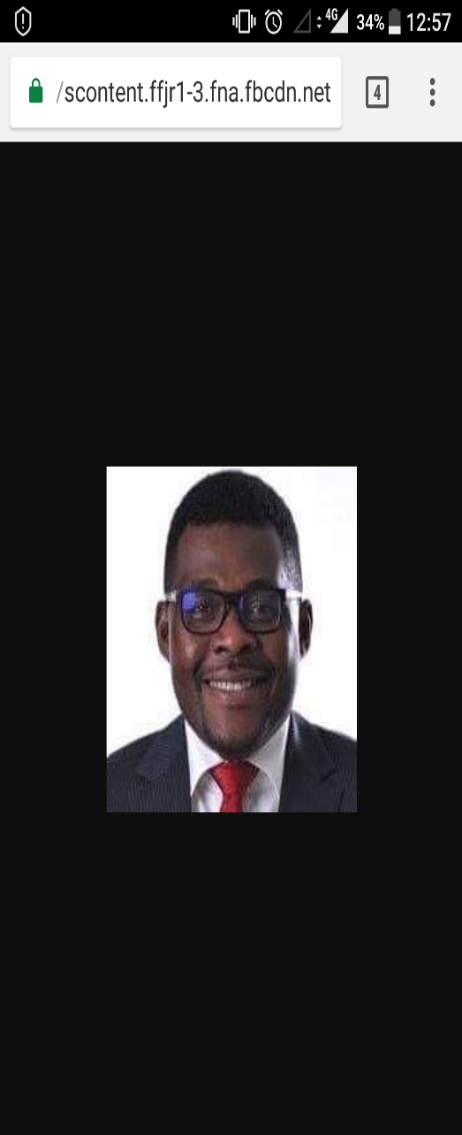TM Philip Nwosisi

**Humorous Speech**

TM Hashim Haleem

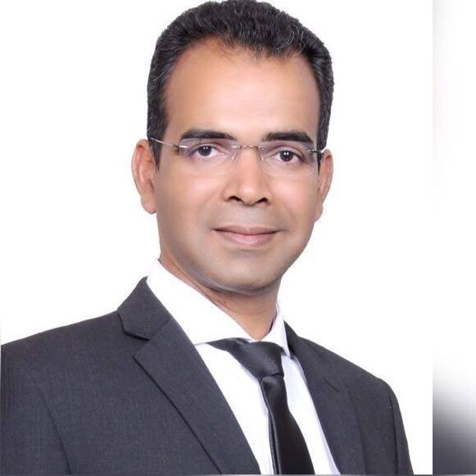TM Aravindakshan

**Area 28**

**International Speech**

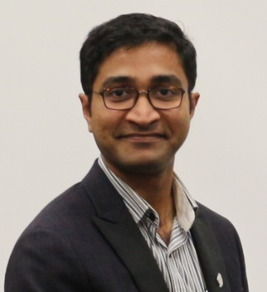TM Jenson George

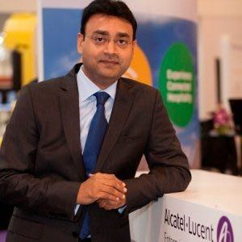TM Ashish Saxena

**Evaluation**

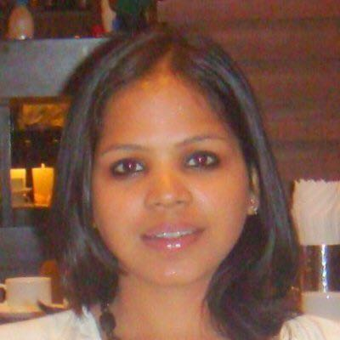 TM Ruchika Airon

TM Jenson George

**Area 28**

**Table Topics**

 TM Ashish Saxena

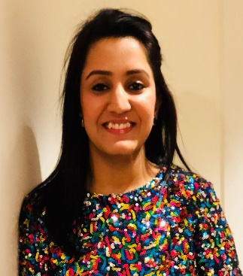 TM Ritika Paliwar

**Humorous Speech**

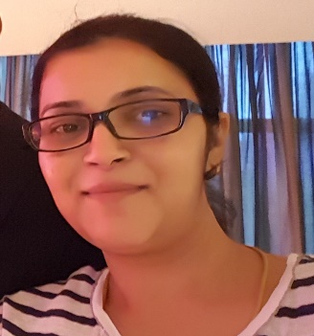 TM Meenakshi Saraswathi

C:\Users\deepa.sukumaran\Downloads\Divn F NL\Venkat Vempati Area 28.jpg TM Venkat Vempati